Testing

**Test Scenario 1:** Check functionality of reading from input file

|  |  |  |  |
| --- | --- | --- | --- |
| **Test Case** | **Test Steps** | **Expected Results** | **Actual Results** |
| Check system behavior when reading valid input file | 1. Launch program  2. Select a valid input file  3. Select “OK” | Ballot will be successfully read from the input file | As expected |
| Check system behavior when reading invalid input file | 1. Launch program  2. Select invalid input file  3. Select “OK” | Error. Program fails and is terminated. | As expected |

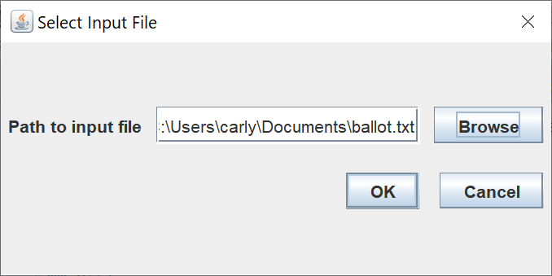

1. Select valid input file

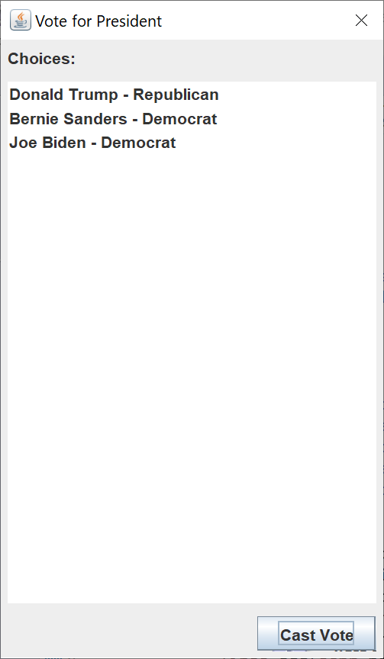

2. Ballot successfully read from input file

**Test Scenario 2:** Check functionality of producing output file

|  |  |  |  |
| --- | --- | --- | --- |
| **Test Case** | **Test Steps** | **Expected Results** | **Actual Results** |
| Check system behavior when writing into valid output file | 1. Browse for and select a valid output file.  2. Select “OK” | Election results will be successfully written to output file. | As expected |
| Check system behavior when writing into invalid output file | 1. Browse for and select an invalid output file.  2. Select “OK” | Error. Program fails and is terminated. | As expected |

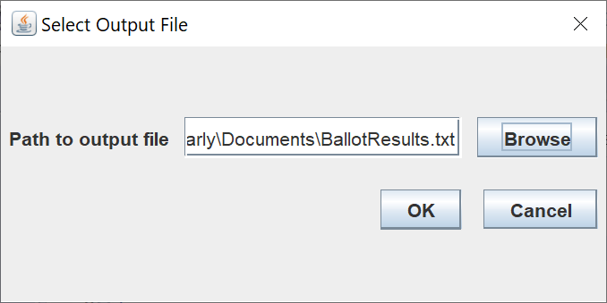

1. Select valid output file

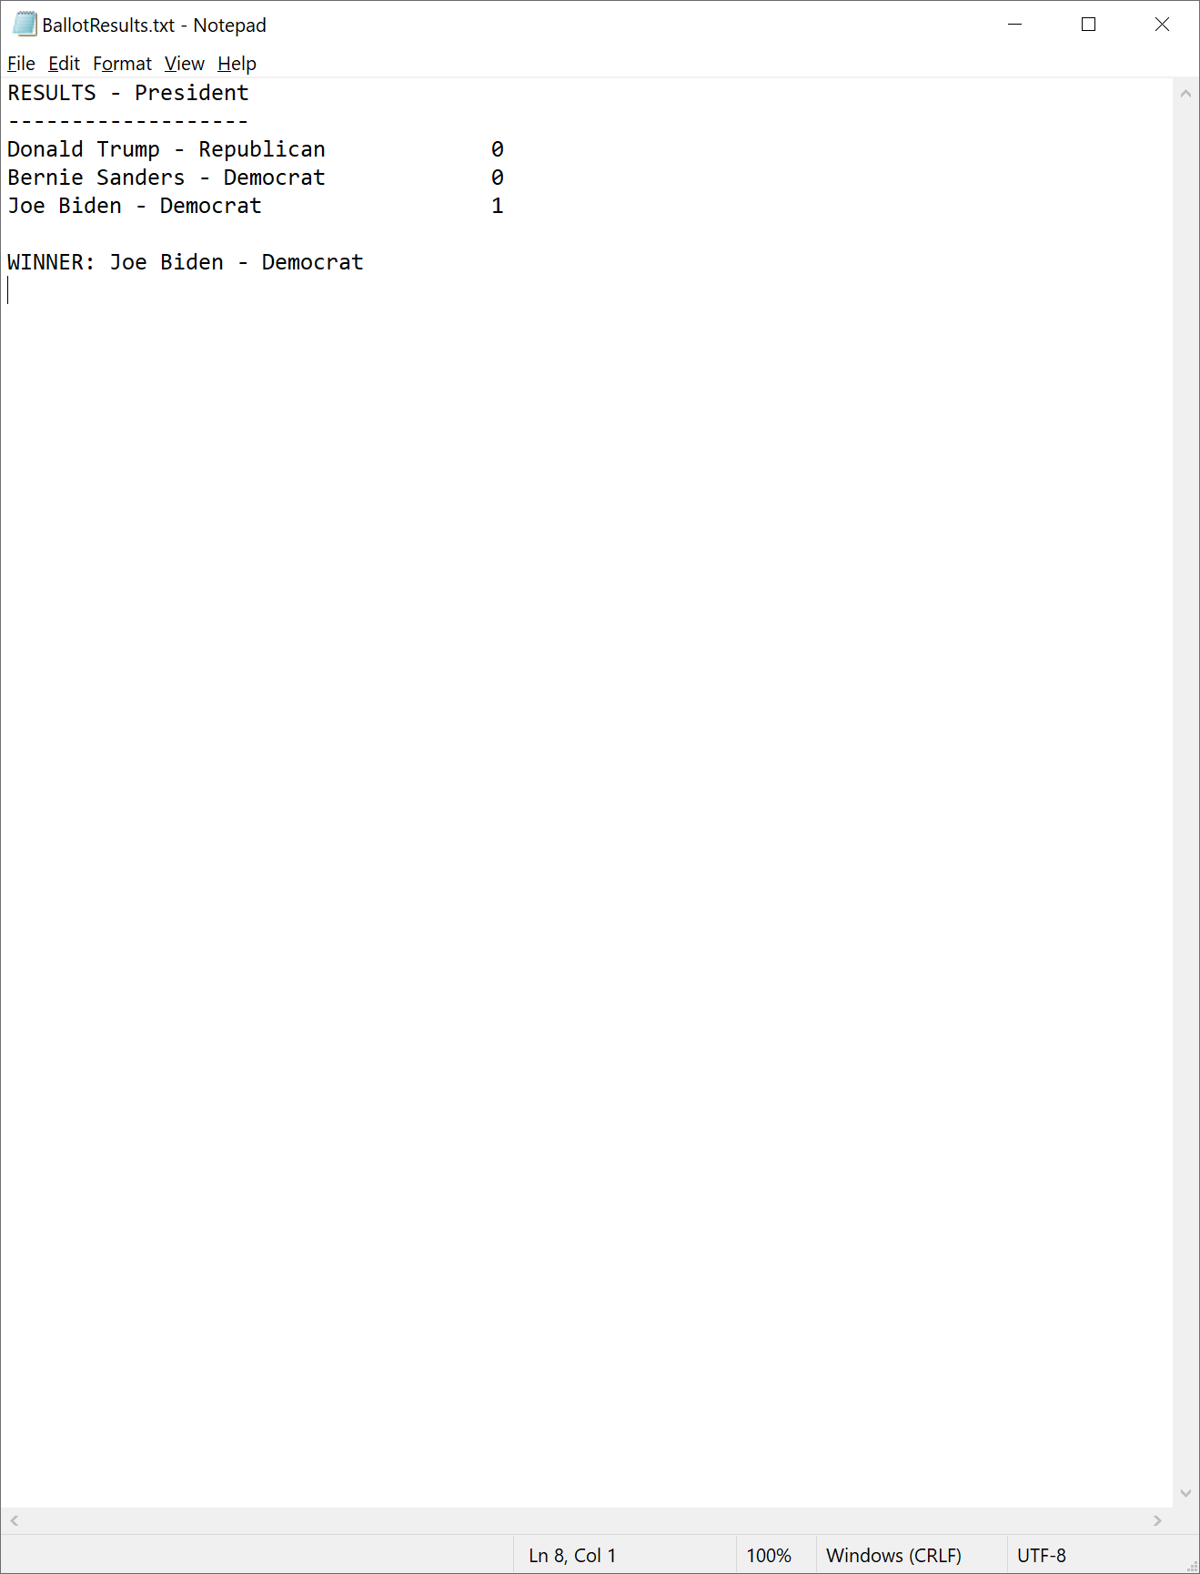

2. Output successfully produced in output file.